Bungendore and District Sheepdog Assoc. Inc
Operating Guidelines August 2016
Dear Members and prospective Members,
Operating Guidelines for BADSA (Bungendore and District Sheepdog Assoc. Inc.) are important for the long term interest of the Club, health and welfare of our instructors, members, our dogs and the welfare of the sheep.

Training days are provided for you and your dog to learn to work sheep in an acceptable manner. Not all dogs make working sheepdogs. The Instructors and Committee will assess if a dog is suitable.
These guidelines give us all, beginners and the experienced an outline of our training days.
Please familiarise yourself with the Guidelines to make training days smooth running, successful and enjoyable.
Regards
BADSA Committee

Training Day held at: Bungendore Showground, Matthews Lane, Bungendore.
Time: 8.30 to 2.00, then pack up
Cost: $10 annual membership.
$25 training day + $5 Showground usage. Total for a training session = $30

Contact before training day: Secretary- Linda Dening 38 Tomboye Rd, Tomboye, 2622
PH: 48459022
Email: tomboyeroad@gmail.com
Contact on Training Day: Sarah Sydrych PH: 0403257243
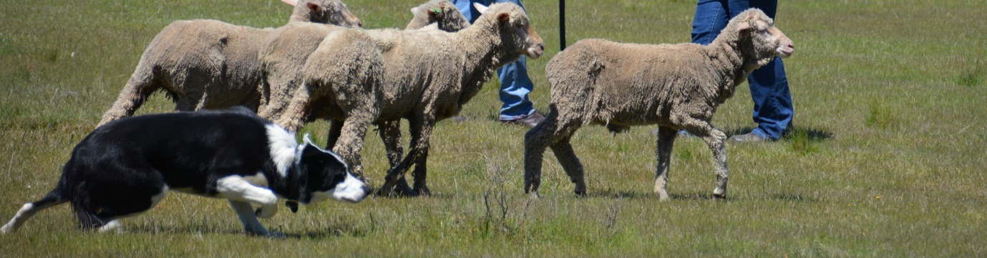
Bungendore and District Sheepdog Assoc. Inc.
What we are About:
- A working sheepdog club.
- A learning and social environment for people and dogs.
- To promote good stock work.
- To hold sheepdog training days for members.
- To facilitate the running of the Trans-Tasman Dog Trial at Bungendore.
- The Instructors are highly skilled and regarded members of NSW Sheepdog Assoc.
Guidelines:
Members
- To record their turns with the instructor on the board provided, in fairness for all members.
- Turns are related to handlers, not the dogs. Therefore the handler chooses which dog they want to work in that particular session.
- Provide leads and water bowls for their dogs.
Dogs
- To be treated with care and responsibility.
- To remain on lead while not training and when entering training session.
- To be tied up away from the sheep and the training area.
- Off lead time is before the training starts and when pack up is completed.
- Are the responsibility of their owner/handler at all times, this includes control of barking.
- Any training aids must be approved by the committee and Instructors.
Sheep
- Are to receive a high level of care having regard to animal welfare standards.
- Handlers must at all times act to protect the sheep.
Correspondence
For ease of management all correspondence will be sent electronically.
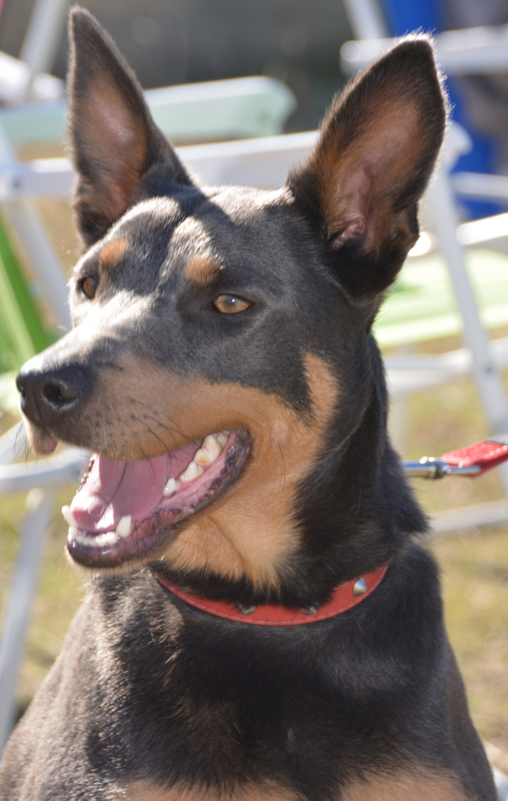
If this is not possible please make other arrangements with the secretary.
Linda Dening Secretary Phone- 02 4845 9022 Email: tomboyeroad@gmail.com
Sarah Sydrych Presedent Phone- 0403 257 243 contact on training day
BADSA Training days

BADSA ( Bungendore and District Sheepdog Assoc Inc) training day starts with the sheep being brought to the Showground. We aim to have the sheep at the Showground by 8.30 and then set up the equipment. Training sessions should start between 8.30 -9.00.
We would appreciate members to be there at 8.30 to help set up and/or pack up.
Each training day will begin with a brief introduction to the day’s activities and this will include all participants and Instructors.
We aim to have 2 and hopefully 3 sessions per person depending on the number of people attending. Each person is to record their turn on the whiteboard provided. Remember your session only relates to you, and you decide which dog to take to each session. Each session will be timed for fairness and it will be at the Instructor’s discretion if the session is shortened or lengthened.
Everyone, experienced or inexperienced, working a dog must begin each session with their dog on a lead.
First time dogs will start with an Instructor who will cover basic good handling skills of sheepdogs and an introduction to sheep. Participants will need to demonstrate a recall of their dog, and on/off lead control, before working with sheep.
Each member and their dog will be assessed by the instructor before moving onto the next group.
Please be aware all dogs need to be toileted and exercised before going into the training area.
All dogs are to be tied away from the working areas except when preparing for your turn.
We break for morning tea and lunch. Members are invited to bring something to share for morning tea. The Club provides tea and coffee. Please bring your own lunch and a chair…… and remember your dog leads for tying up and leading.

