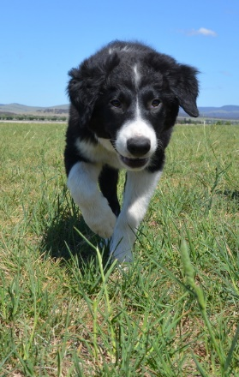

CARDS FOR SALE

4 BLANK CARDS – IMAGES OF WORKING DOGS
2 PACKS OF CARDS TO CHOOSE FROM – 4 DIFFERENT IMAGES IN EACH PACK

$8 PER PAC K, OR 2 PACKS FOR $15

