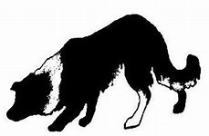
Bungendore & District Sheepdog Assoc. Inc.

Trans Tasman Sheepdog Trial

Thursday 19th July to Sunday 22nd July 2018
Held at the Bungendore Showground
Matthews Lane, Bungendore.

Camping Facilities Available
Food and Refreshments Available During the Day

Entries Close: Monday, 25 June.

Please note this will be a one run trial with finals held on Sunday.

Judges: | Open, Improver  and Novice | Mr Paul Darmody  Mr John Perry  Mr Mick Hudson  (2 judges will judge each round.)
 | Encourage | Mr Tony Mulvihill

A framed portrait of the winning dog in the Open event, donated by Linda Dening
The Barbara Stitt Memorial Novice Trophy
Encourage Trophy donated by Suzanne Clubb

 | Encourage: Entry $7.00 | Novice:Entry $12.00 | Improver : Entry $11.00 | Open : Entry $14.00
1st | $50 trophy+sash | $250 trophy+sash | $200 trophy+sash | $300 Portrait+sash
2nd | $30 + sash | $100 + sash | $100 + sash | $200 + sash
3rd | $20 + sash | $50 + sash | $ 50 + sash | $150 + sash
4th | Sash | Sash | Sash | $100 + sash
5th | Sash | Sash | Sash | $50 + sash
6th |  |  |  | Sash

Entries and Enquiries to: |  | Enquiries to:
Sarah Sydrych | 45 Arena Place,  Royalla, NSW, 2620 | Linda Dening | tomboyeroad@gmail.com  02 48459022
 | 02 62350275  0403257243  sarah.sydrych@gmail.com |  | 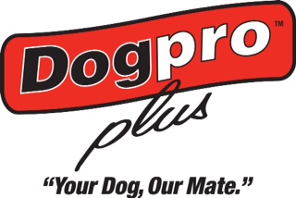
For course rules and entry forms go to: www.workingdogschool.com
Bungendore & District Sheepdog Assoc. Inc.

Trans Tasman Sheepdog Trial.
19thJuly to 22nd July 2018. Starting at 7.30 am

Entry Form
Entries Close: Monday 25th June 2018
Name:
Postal Address:
Email:
Phone:

I ………………………………………………………………………………………………. acknowledge that working with sheep may put me at risk of illness or injury and that in attending this trial I accept that I may be injured from both foreseen and unforeseen events associated with working sheep and dogs.
I will not hold NSWSDWI, the committee or any member of the association responsible for any illness or injury that may occur as a direct result of attending this trial. Handler/owner certify that the entered dog is not a hazard to persons, dogs, stock or property.

Signature……………………………………………………………………….. Date:……………………………………………….
Member of NSW Sheep Dog Workers Inc:- Yes No

Dog: Prefix & Name | Reg. No | Encourage  $7 | Novice  $12 | Improv.  $11 | Open  $14 | TOTAL
Camping $10 a night
 |  |  |  | TOTAL

Saturday Night: Delicious Dinner in the Showground Canteen. $15 per person.
Please indicate numbers attending………..

Payment can be made by bank transfer, money order, or cheque to:
Bungendore & District Sheepdog Assoc. Inc.: Bendigo Bank BSB: 633000 Acc: 159012715

Send Entries to: Sarah Sydrych 45 Arena Place, Royalla, NSW, 2620

Thankyou to our sponsors:
Dog Pro
Queanbeyan Palerang Regional Council
Linda Dening
Suzanne Clubb

A particular Thankyou to Paul Darmody for the supply of the sheep, setting up the course and mentoring our sheepdog club members, both experienced and beginners and especially for his help with the Trans Tasman Trial
Thankyou to Infigen for their donation towards the bridge.

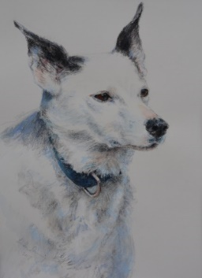
Portrait by Linda Dening.
MGH Meg, Winner of the Open Trans Tasman Trial 2017

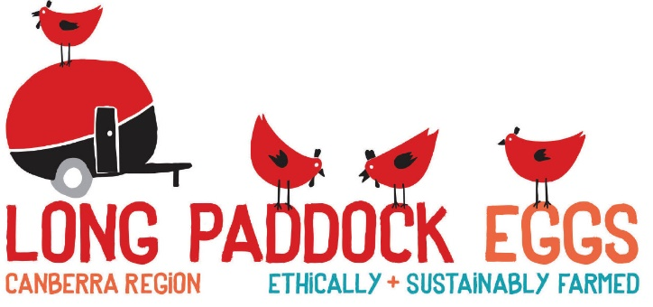

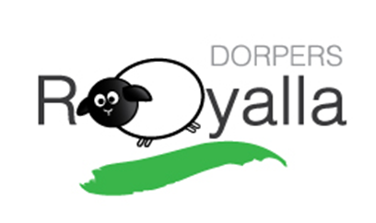
Eileen Moriarty Paul Darmody

The Sheep to Meat
Harry & Sarah Sydrych

